Practical No. 9
Aim : Implement wireless network.

Name : Danish Altaf Solkar | Class : CO - B
Enrolment no. : 24111590805 | Batch : 2

- Turn on wifi
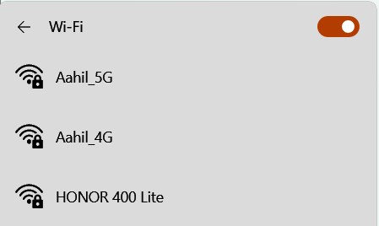

- Available networks


- Choose network
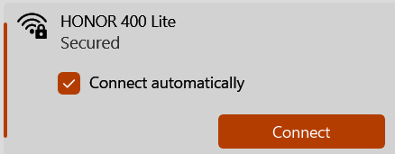

- Enter the password
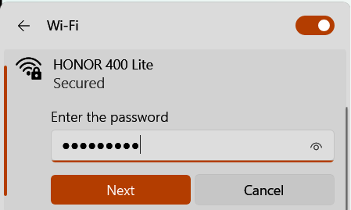

- Successfully connected
